Wireshark – A tool for uncovering packets
- Akash Shrivas Ravishankar
Repository link: https://github.com/frasperclip/wireshark
Project Overview
Wireshark is a network packet analyzer tool. It is a free, open source tool which can be used to observe how packets are traversed to and fro within networks. Wireshark provides details on the source and destination of a packet, its frame size, the protocol followed by the packet, and various other details. It demonstrates the working of data communication and networks in one’s own Wi-Fi connection.

Wireshark cannot detect errors, or issues within a network explicitly, but a network security engineer, or an administrator can use Wireshark to examine the packet flow in networks to troubleshoot network problems.
Wireshark is useful to people with different levels of technical understanding, depending on how deeply they want to inspect network traffic. Developers can use Wireshark to debug various protocol implementations to test their product over the internet, whereas beginners can learn about captured packets, when and why certain packets are retransmitted, analyze packet headers and distinguish different protocols

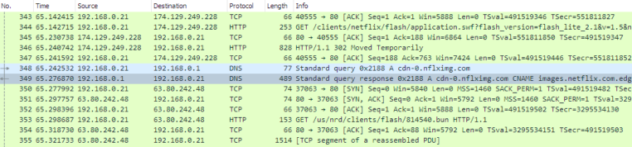
Contents of captured packets and their traversal via the network

Repository Structure
Link of Wireshark’s repository:
https://github.com/wireshark/wireshark
https://gitlab.com/wireshark/wireshark (DEPLOYED HERE)
Important directories and files
- epan/: "Enhanced Packet ANalyzer", the packet analysis engine. It holds the protocol tree, the display filter engine (epan/dfilter) and the dissectors.
- epan/dissectors/: Where the protocol dissectors live, one file per protocol (for example packet-tcp.c). Each dissector decodes the bytes of one protocol, which is what lets Wireshark show packet details.
- wiretap/: Library for reading and writing capture files such as pcap and pcapng and many other formats from other tools.
- ui/qt/: The graphical interface of Wireshark. This is the one part written in C++, using the Qt framework.
- plugins/: Dissectors and other features built as separate plugin modules instead of being compiled into the core.
- extcap/: External capture programs, for capturing from sources other than normal network interfaces.
- dumpcap.c, tshark.c, editcap.c (root folder): The command line tools. dumpcap is the capture engine and the only part that needs elevated privileges, tshark is the command line version of Wireshark, and editcap edits capture files.
- doc/: Man pages, READMEs and the source of the User’s Guide, Developer’s Guide and release notes.
- test/: The automated test suite (pytest based) with sample capture files used for testing.
- tools/ and cmake/: Helper scripts for developers (code checks, generating files) and the CMake modules used for building.
- packaging/: Files used to make installers for different platforms.
Main code and Documentation
- Main code: epan/, wiretap/, ui/ and the C files in the root folder.
- Documentation: doc/ in the repository, plus the official User’s Guide and Developer’s Guide at wireshark.org/docs.
- Tests: the test/ folder.
- Setup and build instructions: README.md, INSTALL.md, CMakeLists.txt in the root, and the Build chapter of the Developer’s Guide.

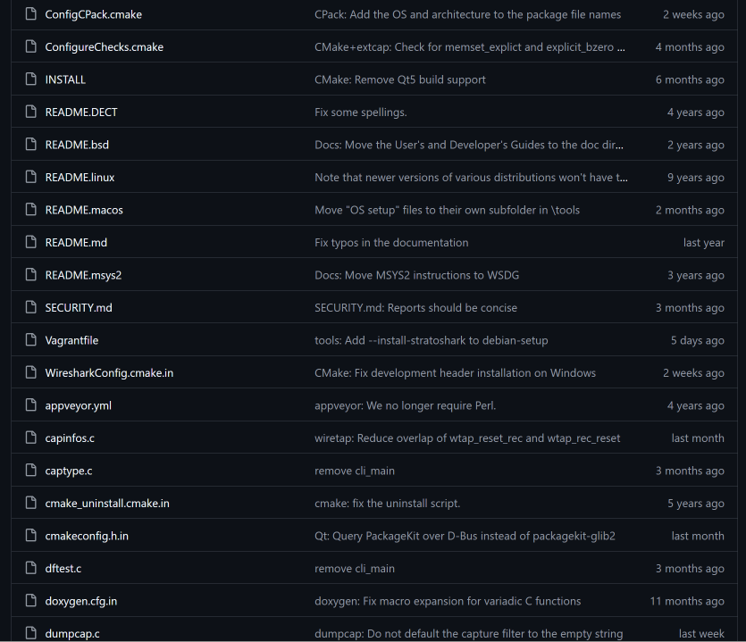
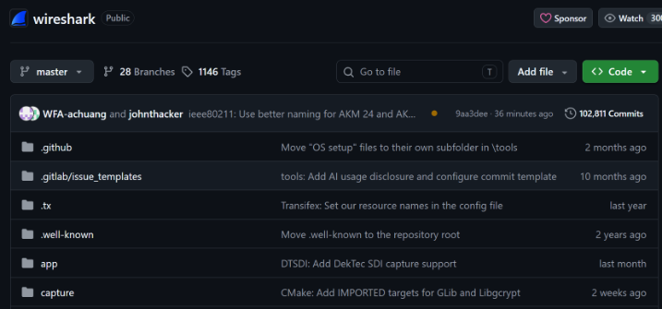

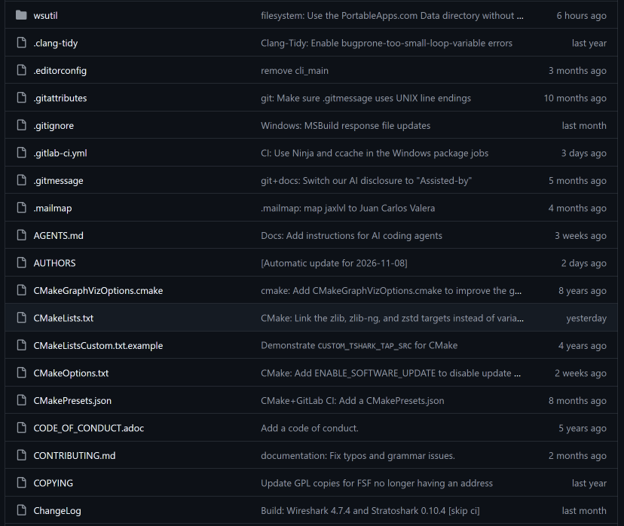
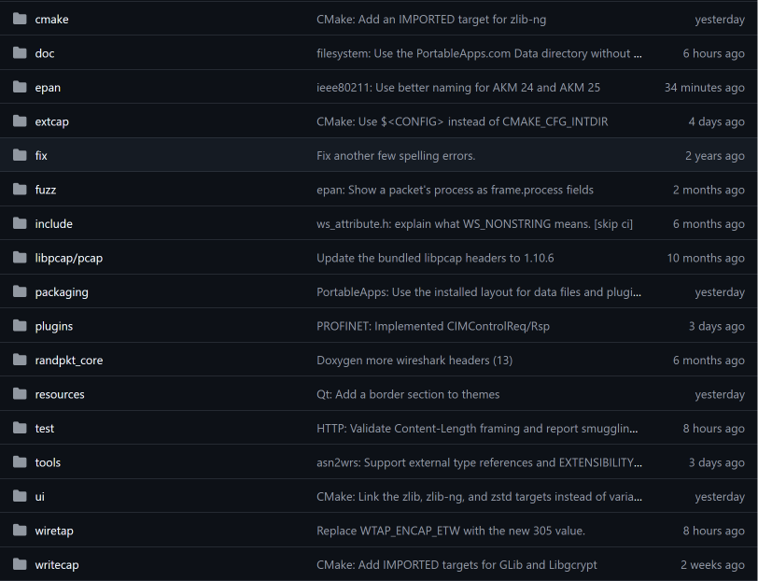

Technologies Used
Most of Wireshark is written in C, and the dissectors are mostly C11. The Qt user interface in ui/qt is the exception and is written in C++. Python is used for the test suite and some helper scripts, and dissectors can also be written in Lua, which is easier for quick experiments.
- Languages: C, C++, Python, Lua.
- Frameworks and libraries: Qt (GUI), GLib (utility functions), libpcap on Linux/macOS and Npcap on Windows (packet capture), and optional compression libraries such as zlib for reading compressed capture files.
- Build tools: CMake, together with a normal C/C++ compiler toolchain.
- Testing and docs: pytest for tests, and AsciiDoc based documentation.
- Version control and CI: Git, with GitLab CI pipelines that run on merge requests.
Contribution Workflow
Wireshark uses GitLab. Bugs and feature requests are reported as issues, and code changes are submitted as merge requests (the GitLab version of pull requests). Only a few maintainers can push directly, so everyone else follows the fork workflow from the Developer’s Guide:
- Fork the repository on GitLab and clone it locally.
- Create a branch and make the change, following the project’s code style guide.
- Write a clear commit message and run the tests.
- Push the branch to my fork and open a merge request against master.
- Respond to review comments and update the merge request until a maintainer merges it. The automatic pipeline also has to pass.
Pull request I looked at
I looked at pull request 719fbc53(Github): "adler: Use zlib’s version if available to benefit from any optimisations", committed by Anders Broman in May 2024. From its title, it changes the Adler-32 checksum code so that Wireshark uses the version that comes with zlib when zlib is installed, instead of its own copy. This matters because zlib’s version can be faster, and checksums are calculated for a lot of packets.
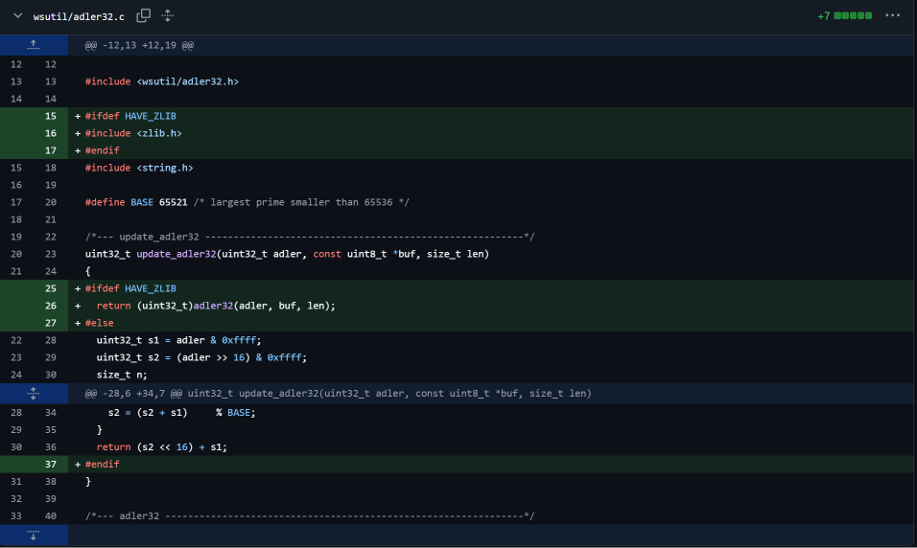
Green highlighted lines are added by Anders Broman during his commit on May 29th,2024
What feature I would add
At face value, wireshark seems extremely complex to a beginner. Therefore, I would implement a beginner view layout of wireshark so new users can slowly get accustomed to the user interface of wireshark as they learn more and more about packets, dissecting and IP Addresses.
Something Interesting I Noticed
What caught my attention was how the capture part and the analysis part are kept separate. Capturing needs special privileges, so Wireshark puts it in a small program called dumpcap, and the rest of the program (dissectors and interface) runs as a normal user. This is a good security design, because a bug in a dissector, which handles untrusted data from the network, cannot easily take over the whole system.

References
- Wireshark repository (GitHub mirror): https://github.com/wireshark/wireshark
- Wireshark repository (GitLab): https://gitlab.com/wireshark/wireshark
- Pull request 719fbc53: https://github.com/wireshark/wireshark/commit/719fbc53
- Wireshark Developer’s Guide: https://www.wireshark.org/docs/wsdg_html_chunked

